1.List the empno,ename,jobtitle,and hiredate of employee from the employee table.







2. List the name,salary of the employees who are clerks.







3. List the name,job,salary of every employee joined on ‘december 17,1980’,



4. List name and annual salary of all the employees.

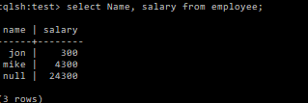

5. List the department name & deptno for departments having deptno.>=20



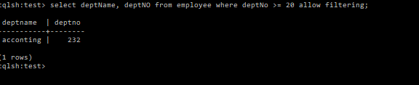

6.Display employees’ names, salary and manager values of those employees whose salary is 500 from EMP table using SELECT statement.



7. Write a query that displays enames with first letter capitalized and all other letters in lowercase and length of enames whose enames start with J, A or N.